Plumpton Primary School
The Plumpton Perch
After School Club
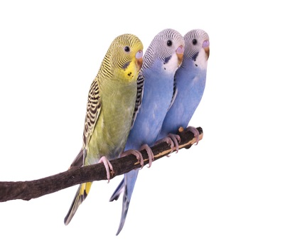
Monday – Thursday : 3.00 - 5.30 pm
Shorter sessions available (see information below)
PARENT /CARER INFORMATION LEAFLET
Introduction  The Plumpton Perch After School Club aims to provide excellent childcare for children in Reception through to Year 6. It is run in line with the values and ethos of Plumpton Primary School.  The Plumpton Perch After School Club provides a ‘homely’ atmosphere with time for relaxation, activities and a snack time. In addition, drinks and fruit are available throughout the session. The club is based in the Perch, but this is not exclusive and the children will be able to use other rooms and facilities within the school dependent on the activities the children are enjoying.  Opening Times  The club runs from 3pm - 5.30pm on Monday to Thursday during term time with different length sessions on offer.  The club is not open on INSET days or if the school is closed for any other reason.  Refunds  Refunds will only be given in exceptional circumstances at the discretion of the Executive Head Teacher, or for absence due to illness of more than two days.  Places  The Plumpton Perch After School Club has 15 places per day available. If there is sufficient demand, we will try to create additional spaces, dependent on staffing and room availability. If there is insufficient demand, or other problems, the club will close. Should this be the case, we will give a minimum of six weeks’ notice.  Booking and Payment:  Please complete and return the attached form, and pay on line by parent pay in the usual way: If you are unable to pay online please send cash to the office in a sealed and clearly named envelope. Bookings can be made up to one term in advance e.g. in Term1 for Term 2.  Please note that bookings will only be secured once payment has been made. Should you book and pay but a place is not available, you will be notified and a full refund given  Additional booking forms are available from the school office.  We do not need any other forms to be completed as we have details of medical conditions, emergency contacts etc. in school already.  All bookings are strictly on a first come first served basis. Siblings will be given priority when appropriate.  Collecting Your Child  The club is based in ‘The Perch’ and you should collect your child from there. Please enter the school in the usual way through the front entrance and ring the bell at the front door. Someone will come and let you in to collect your child. | Cost  For bookings made and paid for by the end of the previous week.  Full session: 3.00pm - 5.30pm: £9.50  Half session: 3.00pm - 4.30pm: £5.00  4.00pm - 5.30pm (following an after school club): £5.70  For ad-hoc sessions, if available (not booked the previous week.  Full session 3.00pm - 5.30pm: £11.00  Half session: 3.00pm - 4.30pm: £5.50  4.00pm – 5.30pm (following an after school club): £6.60  These sessions will need to be booked and paid for by 3pm the day before the place is needed.  All sessions must be paid for at least one day in advance.  The school will give at least 4 weeks’ notice of any cost increase.  We are happy to receive child care vouchers. Please see Mrs Hill for further information.  Late Collection Charges  If you are late collecting your child you may incur a charge.  Contacting Plumpton Perch After School Club  Between 3pm and 5.45pm staff at the club can be contacted on 07919531098.  Supervision  Plumpton Perch After School Club is led by Miss Bingham and Mrs Timmins along with staff who are already working in a support role in the school and are known by the children. There are trained first aiders either supervising the club, or on site. If a child has Special Educational Needs we are not able to supply the same level of support as in the school day. You may wish to consider this, or talk with us, before booking a place for your child if this is relevant to you.  We expect the same standard of behaviour and courtesy from children at the Plumpton Perch After School Club as in the school day. If your child is not able to show this they may not be allowed to attend the club.  Other Information  Please contact the Executive Head Teacher or Head of School if you have any suggestions or complaints. If you have any questions, please ask at the school office.

